**“AUTOMATIC WIRELESS WATER LEVEL INDICATOR**

**AND CONTROLLER”**

**A Project Report**

***Submitted by***

**SUBUDHI ANVESH**

***in partial fulfillment for the award of the degree***

***of***

**BACHELOR OF TECHNOLOGY**

**IN**

**Electronics and Communication Engineering**

***Under the esteemed guidance of***

**GAUTAM**



**DEPARTMENT OF ELECTRONICS AND COMMUNICATION ENGINEERING**

**GANDHI INSTITUTE OF ENGINEERING AND TECHNOLOGY**

**GUNUPUR – 765022**

**YEAR 2020-21**

**DECLARATION**

I hereby declare that the project entitled **“Automatic Wireless Water Level Indicator and Controller”** submitted for the B. Tech Degree is my original work and the project has not formed the basis for the award of any degree, associateship, fellowship or any other similar titles.

Signature of the Student: Subudhi Anvesh

Place: Gunupur

Date: 21/01/2021

|  |  |  |
| --- | --- | --- |
| Logo%20GIET%20copy | **Gandhi Institute of** Engineering & TechnologyGUNUPUR – 765 022, Dist: Rayagada (Odisha), India *(Approved* ***by AICTE, Govt. of Orissa*** *and Affiliated* ***to Biju Patnaik University of Technology)***  : 06857 – 250172(Office), 251156(Principal), 250232(Fax),  e-mail: [gandhi_giet@yahoo.com](mailto:gandhi_giet@yahoo.com) visit us at www.giet.org | **ISO 9001:2000**  **Certified Institute** |

**DEPARTMENT OF ELECTRONICS AND COMMUNICATION ENGINEERING**

**CERTIFICATE**

This is to certify that the project entitled **“AUTOMATIC WIRELESS WATER LEVEL INDICATOR AND CONTROLLER”** is the bonafide work carried out by **SUBUDHI ANVESH, University Regd. No.- 1701210127** student of **BACHELOR OF TECHNOLOGY, GANDHI INSTITUTE OF ENGINEERING AND TECHNOLOGY** during the academic year 2017-21 in partial fulfillment of the requirements for the award of the Degree of **BACHELOR OF TECHNOLOGY** in **ECE.**

**GAUTAM SUBHRAJIT PRADHAN**

**ASSISTANT PROFESSOR HOD**

**GIET UNIVERSITY DEPARTMENT OF ECE**

**GIET UNIVERSITY**

**ACKNOWLEDGEMENT**

Any work has to have contributions and supports of a few at least and a bunch at best. It gives me immense pleasure to have an opportunity to express my gratitude to various people directly or indirectly related to my present project work.

I sincerely believe that I was fortunate enough to have come across a group of human beings whose mere mode of living can inspire someone to work wonders. My project guide Mr. Gautam Department of ECE, GIET Gunupur, is paradigm of that suit. He not only encouraged me to pursue my studies but also instilled the self-belief and confidence, which helps me to take on various trivial, serious and inevitable hassles of life.

I am very much thankful to the Head, Department of Electronics and Instrumentation Engineering, GIET, Gunupur, Prof. Subhrajit Pradhan for his valuable suggestions and supports during the project periods.

I would also grab the opportunity to thank entire faculty group for their moral support and cooperation to make this thesis success.

My family has been the axis of my mental strength and their support leaves me with irreparable debt and honest gratitude. Sincere thanks to them for willingly accepting my decision of opting for higher studies.

I would like to express my heartiest gratitude to the central library staff members for their kind co-operation during my work.

I express my thanks to all my friends for their timely suggestions and encouragements.

I might have missed a many more names and they all deserve the best of my feeling for their selfless helps and supports in their own way.

Subudhi Anvesh

**ABSTRACT**

A water level indicator is used to show the level of water in over-head tank, this keep the user informed about the water level at all time and avoids the situation of water running out when it is most needed. Indicator circuit also has display feature. It indicates amount of water present in over-head tank and automatically OFF when the tank is full. It also full the tank when the water level is less tank 30%.

Sustainability of available water resource in many regions of the world is now a dominant issue. This problem is quietly related to poor water allocation, inefficient use, and lack of adequate and integrated water management. Water is commonly used for agriculture, industry, and domestic consumption. Therefore, efficient use and water monitoring are potential constraint for home or office water management system. In the last few decades several monitoring systems integrated with water level detection have been accepted. Measuring water level is an essential task for government and residence perspective. It would be possible to track the actual implementation of such initiatives with integration of various controlling activities. Therefore, water controlling system implementation makes potential significance in home applications.

The wireless connection is used between Transmitter and Receiver circuits. Transmitter and receiver circuit are used at tank and motor switch/control panel respectively.

**CONTENTS**

**TITLE PAGE**

**ACKNOWLEDGEMENTS.............................................................................................4**

**ABSTRACT......................................................................................................................5**

**LIST OF FIGURES ........................................................................................................7**

**INTRODUCTION............................................................................................................8**

**RF AND RF MODULE....................................................................................................9**

**433MHZ RF TX AND RX............................................................................................. 10**

**TX AND RX CIRCUIT DIAGRAM............................................................................. 11**

**ENCODER AND DEOCDER........................................................................................ 12**

**RELAY............................................................................................................................. 13**

**LED AND 7-SEGMENT DISPLAY.............................................................................. 14**

**ATMEGA328P................................................................................................................ 15**

**ADDRESS SELECTOR................................................................................................. 16**

**TRANSISTOR AND DIODE......................................................................................... 17**

**CAPACITOR AND RESISTOR.....................................................................................18**

**VOLTAGE REGULATOR 7805.....................................................................................19**

**BLOCK DIAGRAM.........................................................................................................20**

**SETUP............................................................................................................................... 22**

**OPERATION.................................................................................................................... 23**

**FLOW CHART................................................................................................................ 24**

**ABBREVIATIONS.......................................................................................................... 25**

**FEATURES...................................................................................................................... 26**

**APPLICATIONS............................................................................................................. 27**

**CONCLUSION...........................................................................................................…..28**

**RESOURCE......................................................................................................................29**

**REFERENCE....................................................................................................................30**

**LIST OF FIGURES**

Fig. 1-433 MHz RF Transmitter and Receiver:

Fig. 2-RF Transmitter Circuit Diagram

Fig. 3-RF Receiver Circuit Diagram

Fig. 4-Relay Module

Fig. 5-LED

Fig. 6-3 Digit 7-Segment Display

Fig. 7-ATMEGA328P IC

Fig. 8(a)-Address Selector

Fig. 8(b)-Address Selector

Fig. 9-Transistor

Fig. 10-Diode

Fig. 11-Electrolytic Capacitor

Fig. 12-Resistor

Fig. 13-Voltage Regulator 7805

Fig. 14(a)-Power Supply

Fig. 14(b)-Tx Circuit

Fig. 14(c)-Rx Circuit

Fig. 15-Basic block diagram

Fig. 16-Flow Chart

**INTRODUCTION**

The Water Level Indicator employs a simple mechanism to detect and indicate the water level in an overhead tank or any other water container. The sensing is done by using a set of nine probes which are placed at ten different levels on the tank walls (with probe10 to probe1 placed in increasing order of height, common probe (i.e. a supply carrying probe) is placed at the base of the tank). The level 9 represents the “tank full” condition while level 1 represents the “tank empty” condition.

Most water level indicators are equipped to indicate and detect only a single level. The Water Level Indicator implemented here can indicate up to nine such levels and the microcontroller displays the level number on a seven-segment display. So, not only is the circuit capable of turning Off the water pump, it also indicates that the water level has fallen below the minimum detectable level with 7 segment display. This circuit is important in appliances such as the water cooler where there is a danger of motor-burnout when there is no water in the radiator used up also it can be used in fuel level indication.

In this project we show the water level indicator using ten transistors which conducts as level rises, a relay is also added which will automatically start the water pump as the water level becomes MDL. With the help of this project, we not only show the level of water with the help of seven segment display but also controlled the water pump based upon the water level.

**Radio Frequency-**

Radio frequency (RF) is the oscillation rate of an alternating electric current or voltage or of a magnetic, electric or electromagnetic field or mechanical system in the frequency range from around 20 kHz to around 300 GHz. This is roughly between the upper limit of audio frequencies and the lower limit of infrared frequencies.

These are the frequencies at which energy from an oscillating current can radiate off a conductor into space as radio waves. Different sources specify different upper and lower bounds for the frequency range.

**RF Module-**

As the name suggests, RF module operates at Radio Frequency. This frequency range varies between 30 kHz - 300 GHz. In this RF system, the digital data is represented as variations in the amplitude of carrier wave. This type of modulation is an ASK.

This [**RF module**](https://robu.in/product/433mhz-100-meters-stx882-ask-transmitter-module-srx882-superheterodyne-receiver-module-antenna/)  is a combination of [**RF Transmitter** and **RF Receiver**](https://robu.in/product/rf-transmitter-receiver-module-315mhz-wireless-link-kit-for-arduino/). The transmitter/receiver (Tx/Rx) pair operates at a frequency of **433 MHz.**

The RF transmitter receives serial data and transmits it wirelessly through its RF antenna. The transmission occurs at the rate of 1 Kbps – 10 Kbps. RF receiver receives the transmitted data and it is operating at the same frequency as that of the transmitter.

## Features of RF Module:

* The Receiver frequency 433MHz
* Receiver typical frequency 105 dBm
* Receiver supply current 3.5 mA
* Low power consumption
* operating voltage of receiver is 5V
* The transmitter frequency range 433.92MHz
* Supply voltage of transmitter is between 3V to 6V
* Output power of transmitter is between 4dBm to 12dBm

## 433 MHz RF Transmitter and Receiver:

In many projects, we use RF modules to transmitting and receiving the data because it has a high volume of applications than IR. RF transceiver module will always work in a pair that is it needs a Transmitter and Receiver to send and receive the data.

A transmitter can only send information and a Receiver and can only receive it, so data can send from one end to another and not the other way around.

The RF **Transmitter module consists of three pins namely Vcc, Din and ground** as shown above. The Vcc pin has a wide range input voltage from 3V to 12V. The transmitter consumes a minimum current of 9mA and can go as high as 40mA during transmission. The center pin is the data pin to transmit the signal. This signal modulated using the ASK and then sent on air at a frequency of 433MHz. The speed at which it can transmit data is around 10Kbps.

The RF receiver module has four pins namely Vcc, Dout, Linear out and Ground as shown above. The Vcc pin should be powered with a regulated 5V supply. The operating current of this module is less than 5.5mA. The pins Dout and Linear out is shorted together to receive the 433Mhz signal from air. This signal is then demodulated to get the data and sent out through the data pin.

[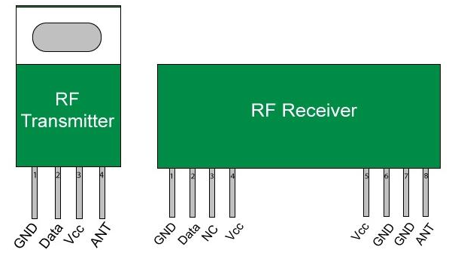](https://aws.robu.in/wp-content/uploads/2020/05/Remote.png)

Fig.1

### RF Transmitter Circuit Diagram

[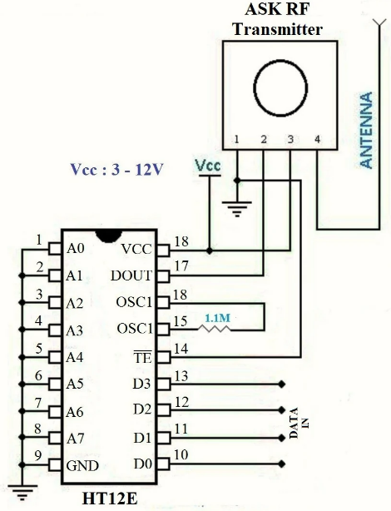](https://aws.robu.in/wp-content/uploads/2020/05/RF-Transmitter-.png)

Fig.2

### RF Receiver Circuit Diagram

[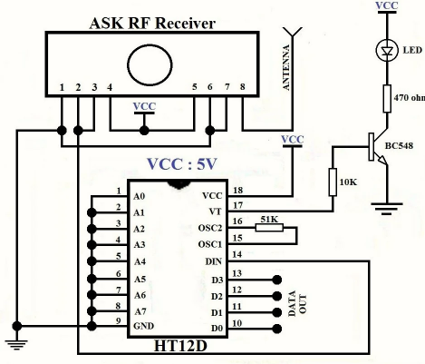](https://aws.robu.in/wp-content/uploads/2020/05/RF-receiver.png)

Fig.3

**Decoders and Encoders-**

The RF modules can also function without the need of Encoder and Decoder modules. Simply power on both the modules with the corresponding voltage mentioned above. Now, make the Din pin on transmitter high and you will find the Dout pin on receiver also goes high. But there is a big drawback in this method. You can have only one button on the sender side and one output on the receiver side. This will not help in building better projects, so we employ the encoder and decoder modules.

The **HT12D** and **HT12E** are 4-data bit encoder and decoder modules. This means that we can make (2^4 = 16) 16 different combinations of inputs and outputs. These are 18 pin IC’s which can operate between 3V to 12V input power supply. They have 4-data bit and 8-addresss bit, these 8 address bits has to be set same on both the encoder and decoder to make them work as a pair.

The **HT12E** is an encoder IC that converts the 4-bit parallel data from the 4 data pins into serial data in order to transmit over RF link using transmitter.

The **HT12E Encoder ICs** are series of CMOS LSIs for Remote Control system applications. They are capable of Encoding 12 bit of information which consists of N address bits and 12-N data bits. Each address/data input is externally trinary programmable if bonded out.

The **HT12D** is a decoder IC that converts the serial data received by the RF Receiver into 4-bit parallel data and drives the output accordingly. It converts serial input to parallel outputs.

The **HT12D Decoder ICs** are series of CMOS LSIs for remote control system applications. This ICs are paired with each other. For proper operation a pair of encoder/decoder with the same number of address and data format should be selected. The Decoder receive the serial address and data from its corresponding encoder, transmitted by a carrier using an RF transmission medium and gives output to the output pins after processing the data.

**Relay Module-**

A Relay Module is an electronic switching device that switches on or off when an external voltage (AC or DC) is applied across its control terminals. It serves the same function as an electromechanical relay, but has no moving parts and therefore results in a longer operational lifetime. SSRs consist of a sensor which responds to an appropriate input (control signal), a solid-state electronic switching device which switches power to the load circuitry, and a coupling mechanism to enable the control signal to activate this switch without mechanical parts. The relay may be designed to switch either AC or DC loads.

It use power semiconductor devices such as thyristors and transistors, to switch currents up to around a hundred amperes.

It have fast switching speeds compared with electromechanical relays, and have no physical contacts to wear out. Users of relays must take into consideration an SSR's inability to withstand a large momentary overload the way an electromechanical relay can, as well as their higher "on" resistance. In relation to mains voltage.

It has 3 pins-

1.Common pin

2.Normally open

3.Normally closed

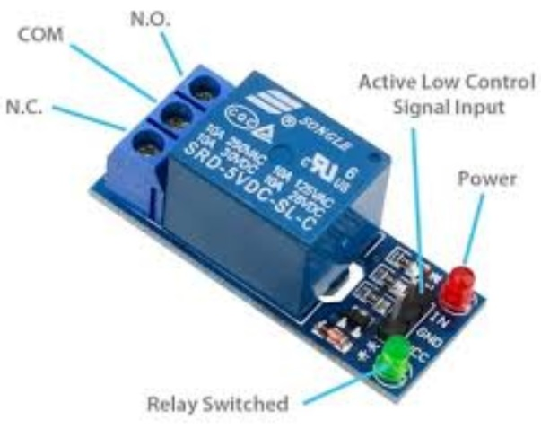

Fig.4

**LED-**

A light-emitting diode is a semiconductor light source that emits light when current flows through it. Electrons in the semiconductor recombine with electron holes, releasing energy in the form of photons. The color of the light (corresponding to the energy of the photons) is determined by the energy required for electrons to cross the band gap of the semiconductor. White light is obtained by using multiple semiconductors or a layer of light-emitting phosphor on the semiconductor device.

Here we use 2 different LED’s which are GREEN & WHITE.

GREEN led indicates that establishment of wireless connection between both Tx and Rx circuits will be displayed.

WHITE led indicates the status of motor of the water tank.

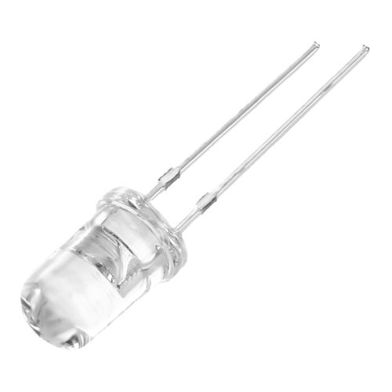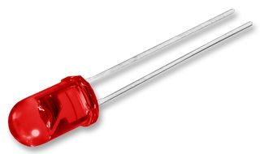

Fig.5

**3 Digit 7-Segment LED Display-**

A 3 digit seven-segment display is a form of electronic display device for displaying decimal numerals that is an alternative to the more complex dot matrix displays.

Seven-segment displays are widely used in digital clocks, electronic meters, basic calculators, and other electronic devices that display numerical information.

The seven segments displays are the oldest yet one of the efficient types of display used in embedded applications. This display has nothing more than 8 LED inside it. These 8 LEDs are separated into each segments which can be named as a, b, c, d, e, f, g. These entire 8 segment LEDs have one end of their pins pulled out of the module as shown above and the other ends are connected together and pulled out as the Common pin. So to make an LED of a particular segment glow we just have to power common pin along with the segment pin. This way we can power more than one segment at a time to represent the numeric number 0-9 and also few Alphabets.

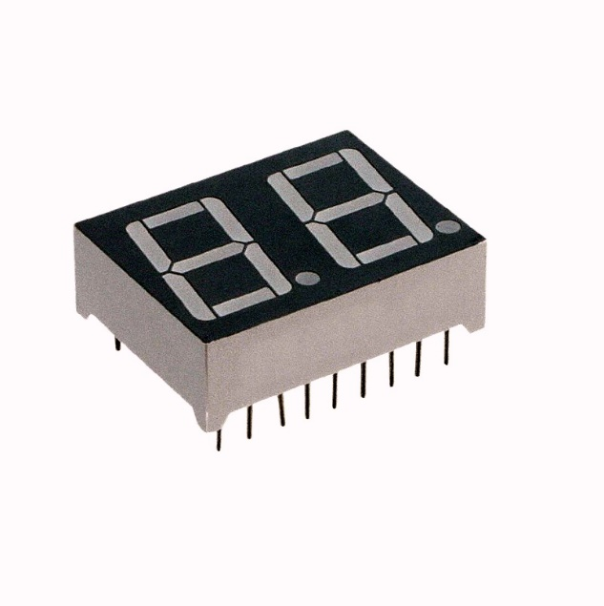

Fig.6

**ATMEGA328P-**

The high-performance Microchip picoPower® 8-bit AVR® RISC-based microcontroller combines 32 KB ISP Flash memory with read-while-write capabilities, 1024B EEPROM, 2 KB SRAM, 23 general purpose I/O lines, 32 general purpose working registers, three flexible timer/counters with compare modes, internal and external interrupts, serial programmable USART, a byte-oriented Two-Wire serial interface, SPI serial port, a 6-channel 10-bit A/D converter (8-channels in TQFP and QFN/MLF packages), programmable watchdog timer with internal oscillator, and five software selectable power saving modes.

The device operates between 1.8-5.5 volts.

By executing powerful instructions in a single clock cycle, the device achieves throughputs approaching one MIPS per MHz, balancing power consumption and processing speed.

**Name Value**

Program Memory Type Flash

Program Memory Size (KB) 32

CPU Speed (MIPS/DMIPS) 20

SRAM (B) 2,048

Data EEPROM/HEF (bytes) 1024

Digital Communication Peripherals 1-UART, 2-SPI, 1-I2C

Capture/Compare/PWM Peripherals 1 Input Capture, 1 CCP, 6PWM

Timers 2 x 8-bit, 1 x 16-bit

Number of Comparators 1

Temperature Range (°C) -40 to 85

Operating Voltage Range (V) 1.8 to 5.5

Pin Count 32

Low Power Yes

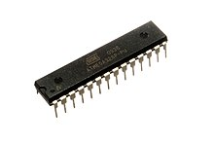

Fig.7

**Address Selector-**

An Address selector is an electronics device that selects single data with multiple inputs.

It mainly used to select the address of HT12D & HT12E in our project.

It is also used to set the MDL of the over-head tank.

Address Selector is very much needed for this project because it will help to pair the RF Transmitter with the correct RF Receiver without any intermediate loss.

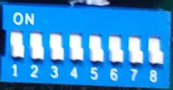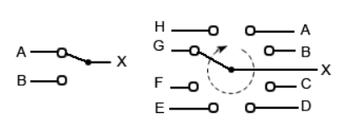

Fig.8(b)

Fig.8(a)

**Transistor-**

A transistor is an electronic component that is used in circuits to either amplify or switch electrical signals or power, allowing it to be used in a wide array of electronic devices. A transistor consists of two PN diodes connected back to back. It has three terminals namely emitter, base and collector. The basic idea behind a transistor is that it lets you control the flow of current through one channel by varying the intensity of a much smaller current that’s flowing through a second channel. It is capable of amplification and rectification.

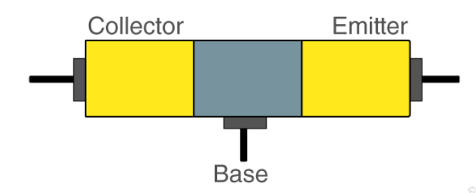

Fig.9

**Diode-**

A diode is a two-terminal electronic component that conducts electricity primarily in one direction. It has high resistance on one end and low resistance on the other end. These devices are used to protect circuits by limiting the voltage and to also transform AC into DC. Semiconductors like silicon and germanium are used to make the most of the diodes. Even though they transmit current in a single direction, the way with which they transmit differs. There are different kinds of diodes and each type has its own applications.

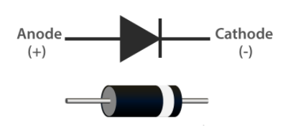

Fig.10

**Capacitor-**

The capacitor is a device in which electrical energy can be stored. It is an arrangement of two-conductor generally carrying charges of equal magnitudes and opposite sign and separated by an insulating medium. The non-conductive region can either be an electric insulator or vacuum such as glass, paper, air or semi-conductor called as a dielectric.

Capacitor vary in shape and size, they have many important applications in electronics.

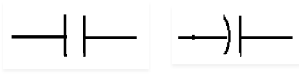

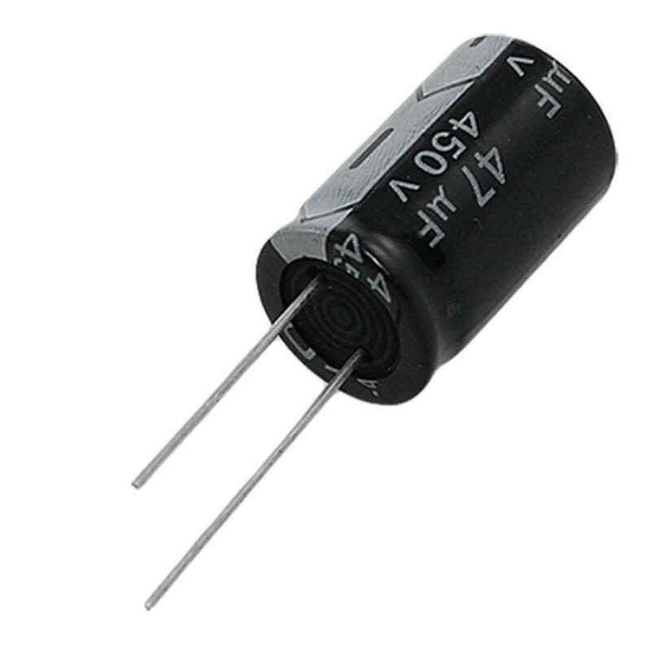

Fig.11

**Resistor-**

A passive electrical component with two terminals that are used for either limiting or regulating the flow of electric current in electrical circuits.

The main purpose of resistor is to reduce the current flow and to lower the voltage in any particular portion of the circuit. It is made of copper wires which is coiled around a ceramic rod and the outer part of the resistor is coated with an insulating paint.

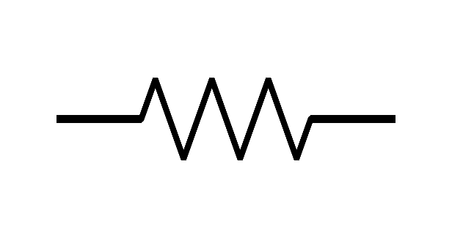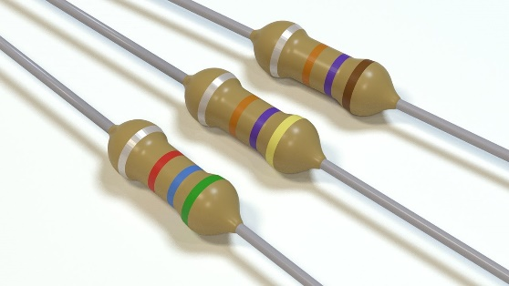

Fig.12

**Voltage Regulator 7805-**

7805 is a three terminal linear voltage regulator IC with a fixed output voltage of 5V which is useful in a wide range of applications. Currently, the 7805 Voltage Regulator IC is manufactured by Texas Instruments, ON Semiconductor, STMicroelectronics, Diodes incorporated, Infineon Technologies, etc. They are available in several IC Packages like TO-220, SOT-223, TO-263 and TO-3. Out of these, the TO-220 Package is the most commonly used one (it is the one shown in the above image).

Some of the important features of the 7805 IC are as follows:

* It can deliver up to 1.5 A of current (with heat sink).
* Has both internal current limiting and thermal shutdown features.
* Requires very minimum external components to fully function.

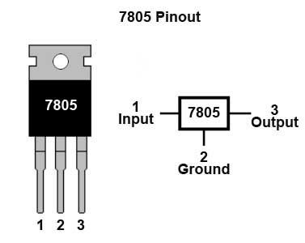As mentioned earlier, 7805 is a three terminal device with the three pins being 1. INPUT, 2. GROUND and 3. OUTPUT. The following image shows the pins on a typical 7805 IC in To-220 Package.

Fig.13

The input voltage should always be greater than the output voltage (atleast by 2.5V).

The input current and output current are almost identical. This means that when a 7.5V 1A supply is given at input, the output will be 5V 1A.

The remaining power is dissipated as heat and hence a heat sink must be used with 7805 IC.

**Block Diagram of Tx & Rx Circuit**

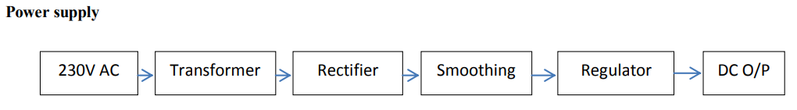

Fig.14(a)

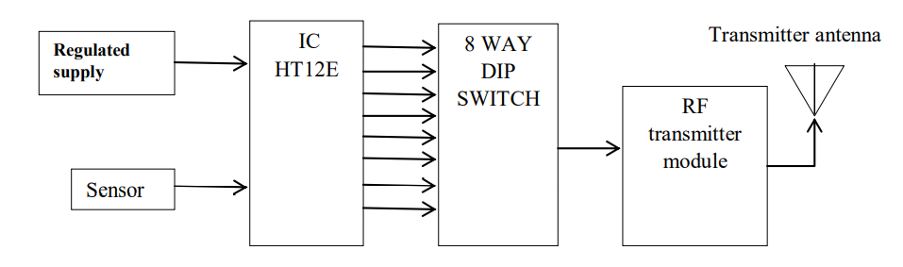**Transmitter Circuit**

Over Head

Tank

10 Level Sensors

Fig.14(b)

**Receiver Circuit**

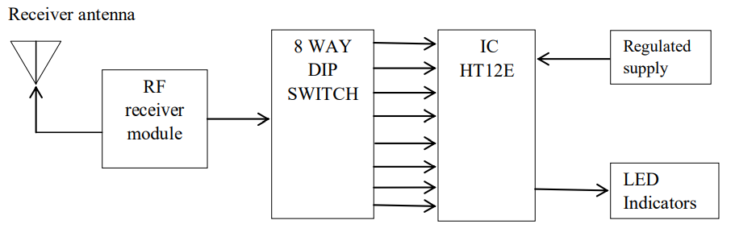

Fig.14(c)

7-Segment Display

**BASIC BLOCK DIAGRAM**

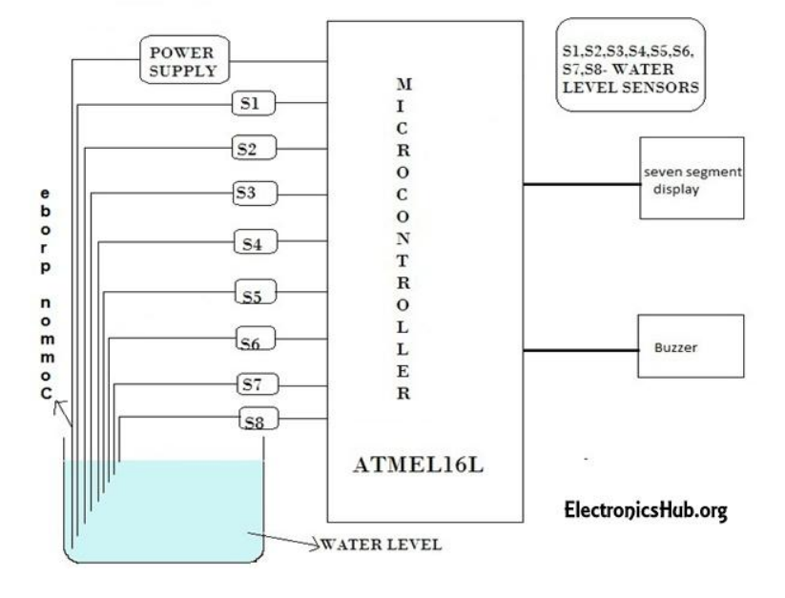

Fig.15

**SETUP**

* Transmitter and receiver circuit are used at over-head tank and motor switch/control panel respectively.
* Transmitter circuit consists of HT12E encoder circuit, RF Transmitter, antenna, 10 Level Sensors, green LED.
* Receiver circuit consists of HT12D decoder circuit, RF Receiver, antenna, 2 digit 7-segment LED display, Relay, green & white LED’s.
* The establishment of wireless connection between both Tx and Rx circuits will be displayed by Green LED Light with blinking.
* The relay is connected to the control panel of the water pump.
* Both transmitter and receiver should be powered with 12V DC supply.

**OPERATION**

The operation of this project is very simple and can be understood easily.

In our project “water level indicator” there are 3 main conditions:

1. There is no water available in the source tank or water is below 3rd level.

2. Intermediate level i.e., either of 4th to 9th level.

3. There is ample amount of water available in the source tank.

So let us discuss on the more about these 3 conditions

**CONDITION 1: Water not available** **or water is below 3rd level**

When the tank is empty or water level is below 3rd level there is no conductive path between any of the 7 indicating probes that means remaining 2 probes are conducting or connected with the common probe at ground level(+5v), so the microcontroller is programmed in such a way that after disconnecting of common probe with the 3rd probe the 3rd transistor acting as a switch will open and then it sends the data to receiver circuit and it will trigger the relay and turn On the water pump.

**CONDITION 2: Intermediate levels**

Now as the water starts filling in the tank a conductive path is established between the sensing probes and the common probe and the corresponding transistors get sufficient biasing at their base, they starts conducting and now the outputs will be Vce (i.e., 1.2v-1.8v) approximately which is given to microcontroller. Here the microcontroller is programmed as a priority encoder which detects the highest priority input and displays corresponding water level in the seven-segment display. In this project while the water level reaches the 10th level i.e., last but one level along with display in seven segment as FULL it also turns Off the water pump.

**CONDITION 3: Water full**

When the tank becomes full, the top-level probe gets the conductive path through water and the corresponding transistor gets into conduction whose output given to microcontroller with this input microcontroller not only displays the level in seven segment display and as discussed it will turn Off the water pump after 3 sec of getting the full signal.

**FLOW CHART**

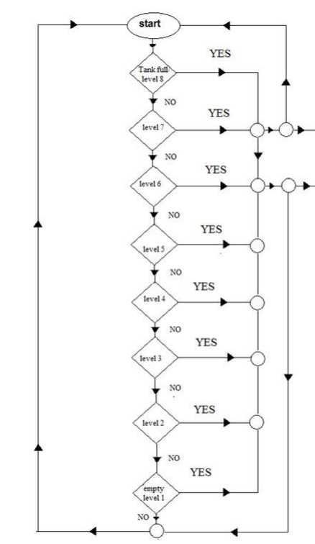

Relay

3 Digit 7-Segment Display

Fig.16

**ABBREVIATIONS**

MDL-Minimum Division Level

RF-Radio Frequency

ASK-Amplitude Shift Key

MHz-Mega Hertz

EEPROM-Electrically Erasable Programmable Read Only Memory

USART- Universal synchronous and asynchronous receiver-transmitter

SRAM-Static Random Access Memory

A/D Converter-Analog To Digital Converter

MIPS- Million Instructions Per Second

ISP Flash Memory-In System Programming Flash Memory

SPI- Serial Peripheral Interface

I2C-Inter Integrated Circuit

**FEATURES**

* Easy installation.
* Low maintenance.
* Compact elegant design.
* The Automatic water level controller ensures no overflows or dry running of pump there by saves electricity and water.
* Avoid seepage of roofs and walls due to overflowing tanks.
* Fully automatic, saves man power.
* Consume very little energy, ideal for continuous operation.
* Automatic water level controller provides you the flexibility to decide for yourself the water levels for operations of pump set.
* Shows clear indication of water levels in the overhead tank.

**APPLICATIONS**

* Automatic Water level Controller can be used in Hotels, Factories, Homes Apartments, Commercial Complexes, Drainage, etc., It can be fixed for single phase motor, Single Phase Submersibles, Three Phase motors. (For 3Æ and Single-Phase Submersible Starter is necessary) and open well, Bore well and Sump.
* Automatic water level controller will automatically START the pump set as soon as the water level falls below the predetermined level (usually 1/2 tank) and shall SWITCH OFF the pump set as soon as tank is full.
* We can control two motor and two sumps and two overhead tanks by single unit.
* Fuel level indicator in vehicles
* Liquid level indicator in the huge containers in the companies.

**CONCLUSION**

The water level Indicator employs a simple mechanism to detect and indicate the water level in an overhead tank or any other water container. The sensing is done by using a set of four probes which are placed at four different levels. We can conclude that this system is very beneficial in rural as

well as urban areas. It helps in the efficient utilization of available water sources.

If used on a large scale, it can provide a major contribution in the conservation of water for us and the future generations. In these days, when the Earth's reserve of consumable water is decreasing every moment, every drop has its value. Water level controller is a simple yet effective way to prevent wastage of water. Its simplicity in design and low-cost components make it an ideal piece of technology for the common man.

**RESOURCES**

How to Make Water Level Indicator – Video 1:

Resource Link: <http://www.youtube.com/watch?v=Zftovgq-6m4>

(Prepared by srinivas srini)

Simple Water Level Indicator Using Transistors – Video 2:

Resource Link: <http://www.youtube.com/watch?v=2eEidOOtD9w>

(Prepared by Navneet Kumar)

Demonstration of Water Level Indicator Project – Video 3:

Resource Link: <http://www.youtube.com/watch?v=aNLMOmwCPzs>

(Prepared by Dipendra Dev Raikut)

Water Level Indicator (from Sunday Projects) – Video 4:

Resource Link: <http://www.youtube.com/watch?v=VQMPquWrGC0>

(Prepared by Junaid Sully)

Water Level Indicator Using 2n2222 – Video 5:

Resource Link: <http://www.youtube.com/watch?v=tPWCKa4Ykh0>

(Prepared by Jibran Shahid)

Simple Water Level Indicator – Video 6:

Resource Link: <http://www.youtube.com/watch?v=cVmqFOWDBUg>

(Prepared by TheKash40)

Simple Water Level Circuit – Video 7:

Resource Link: <http://www.youtube.com/watch?v=DowptWbjiN4>

(Prepared by Bulliondon)

Water Level Indicator – Video 8:

Resource Link: <http://www.youtube.com/watch?v=2qXq0WjqL6g>

(Prepared by Prathamesh Dingankar)

Simple Water Level Indicator – Video 9:

Resource Link: <http://www.youtube.com/watch?v=Ps3wClVK-Ds>

(Prepared by Popescu Marian)

Tank Water Level Indicator – Video 10:

Resource Link: <http://www.youtube.com/watch?v=47cUyoIVQTQ>

(Prepared by Lou Lucano)

**REFERENCES**

* Fundamentals of Electronic circuit design – Hongsen Ma
* Introduction of Electronics -Yatindra Nath Singh
* https://en.wikipedia.org – Wikipedia
* International Journal of Scientific & Engineering Research, Volume 7, Issue 4, April-2016 10

ISSN 2229-5518

IJSER © 2016

* http://www.ijser.org
* www.google.co.in –Google
* Joydeep Kumar Chakraborty, “Water Level Controller”
* Rex Niedermeyer, "Aquarium Water Pumps"